EXPERIMENT NO - 4
AIM: Process Management: Scheduling.
TOOLS/SOFTWARES REQUIRED: Linux OS
THEORY:
Preemptive scheduling: Preemptive scheduling allows the operating system to interrupt a running process to allocate the CPU to another task, enhancing responsiveness and fairness, but it introduces context-switching overhead.
Non-preemptive scheduling: Non-preemptive scheduling requires a process to complete or enter a waiting state before releasing the CPU, ensuring low overhead but potentially causing long waiting times for short processes.
NON-PREEMPTIVE:
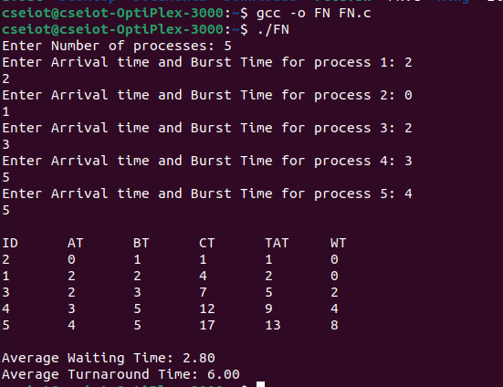
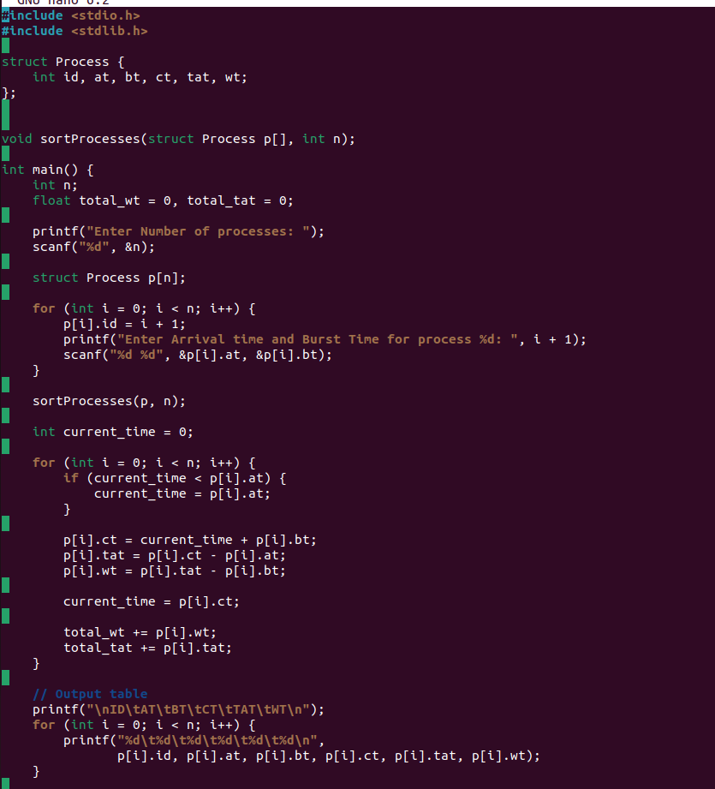
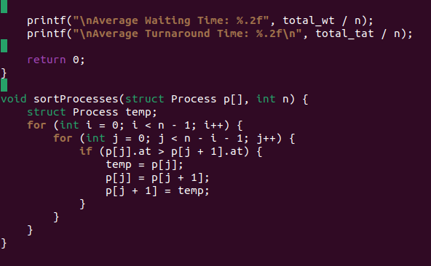

PREEMPTIVE:
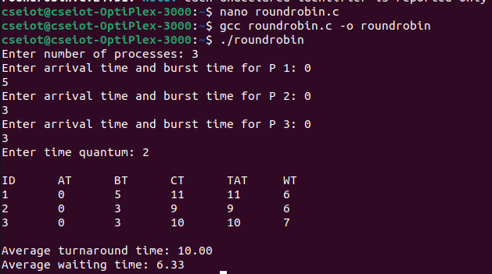
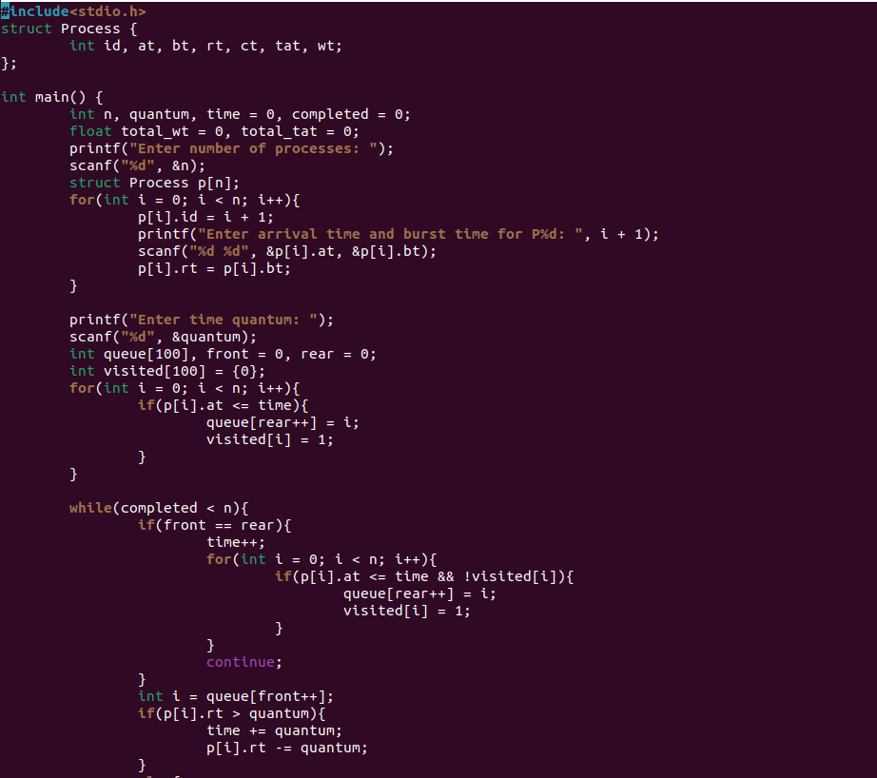
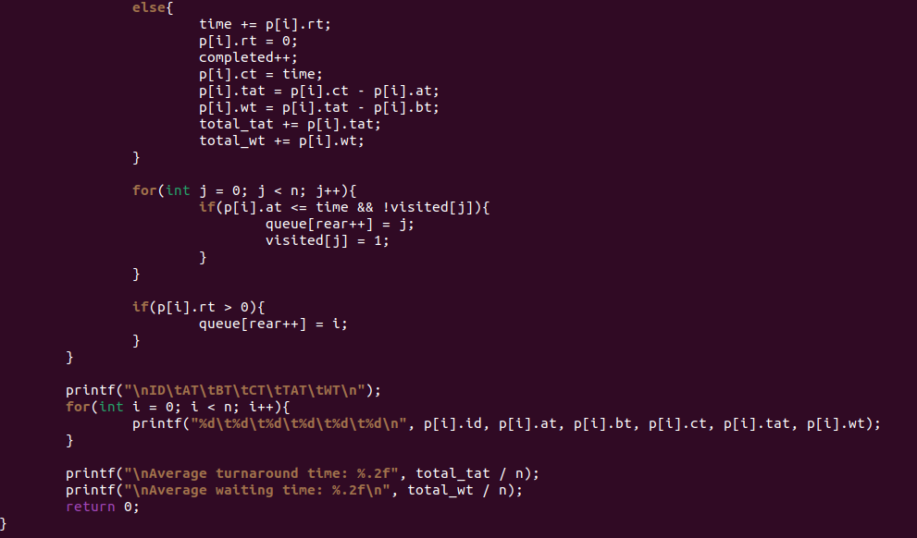

CONCLUSION: Hence, we have learned about non-preemptive and preemptive scheduling algorithms and implemented them in Linux with the C programming language.

